British Legion Volunteer Police
Established 6th October 1938
Disbanded 15th October 1938
Initial strength 1200 officers
Final strength 1200 officers

The British Legion Volunteer Police must have the shortest history on record. It was formed on October 6 1938 to police and supervise the voting in Sudetenland, Czechoslovakia. The volunteers, all members of the British Legion, were issued uniform and boarded two ships. During their voyage the circumstances in Sudetenland changed and they were ordered back to the UK, landing at Tilbury on October 15, where they were disbanded.

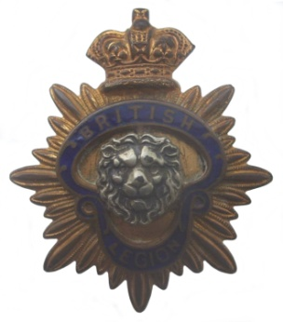 | 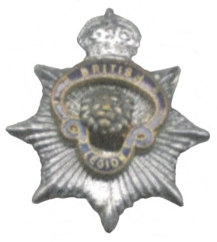 | 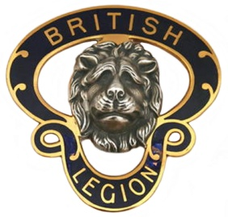
BRT-010  Cap Badge | BRT-020  Collar Badge | BRT-030  Lapel Badge

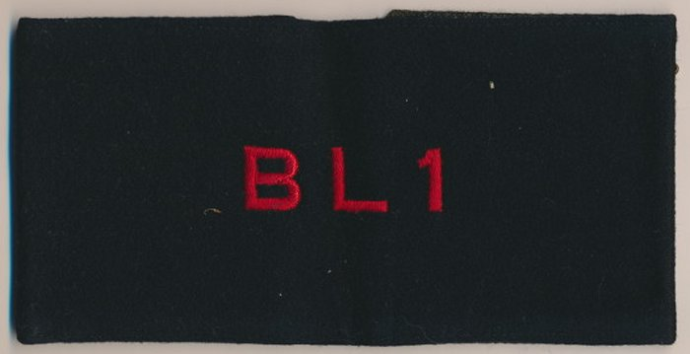
BRT-040
Armband Badge

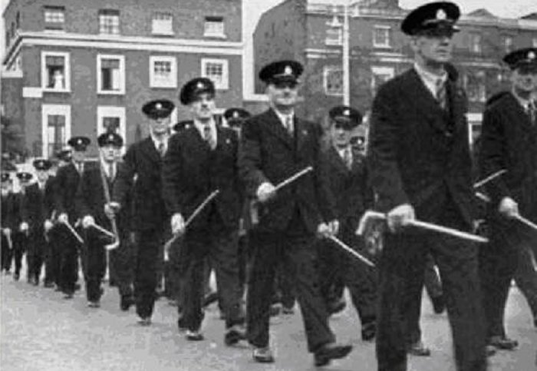
Legion volunteers with issued walking sticks

