Serious Organised Crime Agency
Established 1 April 2006
Became part of National Crime Agency 7 October 2013

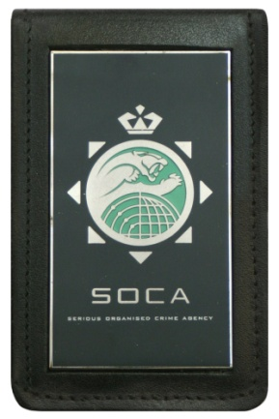
SER-C10
Warrant Card Holder

