Why do we do what we do?
Because it matters!
Part II – Make good and mend
Before I start, for readers mainly from the UK, how many of you still have a pair or three of the super-white cotton gloves that were issued for Royal visits, tucked away in a drawer somewhere? If you are going to embark on photo/negative scanning and archive work, I recommend you get them out now as they will be invaluable to prevent your fingerprints, which contain acid, from marking or damaging fragile artefacts.
In part 1 I gave a little background to some of my objects. In part two I would like to share some knowledge I have gained about how to keep, repair and restore artefacts. I am not going to go into huge amounts of detail, rather I will give you the basics and point to other websites where more information and detailed instructions can be obtained.
Over the last 12 years I have moved around the globe and have lived in several countries. A 40 foot container with my worldly goods has usually followed me around, however because household goods have had to be put in storage, sadly some items have gone missing and dampness/humidity have also caused problems, even though protective measures were taken.
Such things cannot be avoided, and gradually as artefacts age – depending upon what they were made of and the environment they were kept in and you are in – they will to a greater or lesser degree degrade. What we should be doing is to arrest the degradation where we can and make copies for the future.
Now living in Arabia, where it is hot all year round, and very hot (over +50°c) in summer, the air conditioning just sucks the moisture out of everything. Shrinkage and splitting of wood is a major issue. However, there is still humidity and being less than 5km from the sea, the ever present afternoon wind off the ocean brings warm, moist, salt laden air. There is a problem in trying to maintain a stable atmosphere for artefacts, it is just a different problem to the cool wet summers and cold wet winters I remember from my days in the UK. The one constant is corrosion – things still go rusty here!
When my container followed me to my present posting, I discovered that a very small number of my carefully archived 5x4 camera negatives had degraded in the 5 years since I had really last looked at them. They were all from the Grimsby Borough Police, and were all from the early 1950’s. Out of over 1,000 negatives, there were perhaps 14 which were damaged. Sadly they were negatives where I did not have any prints and they had not been scanned.

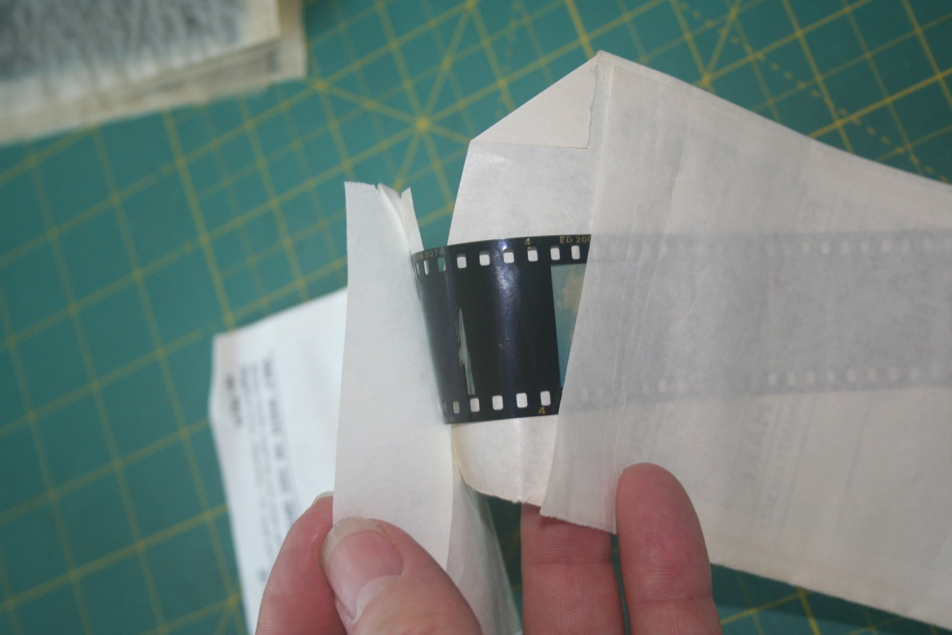
One or two strips of colour negatives had stuck to the envelopes they were in. This example is not filed in a strip film holder, however strips in long holders had also stuck to the cellophane, so it was not just a problem of not being stored in the exactly correct medium.
All my photographs, negatives and slides have been stored in acid free, alkaline neutral museum archive boxes, to which I have now added larger desiccant sachets.

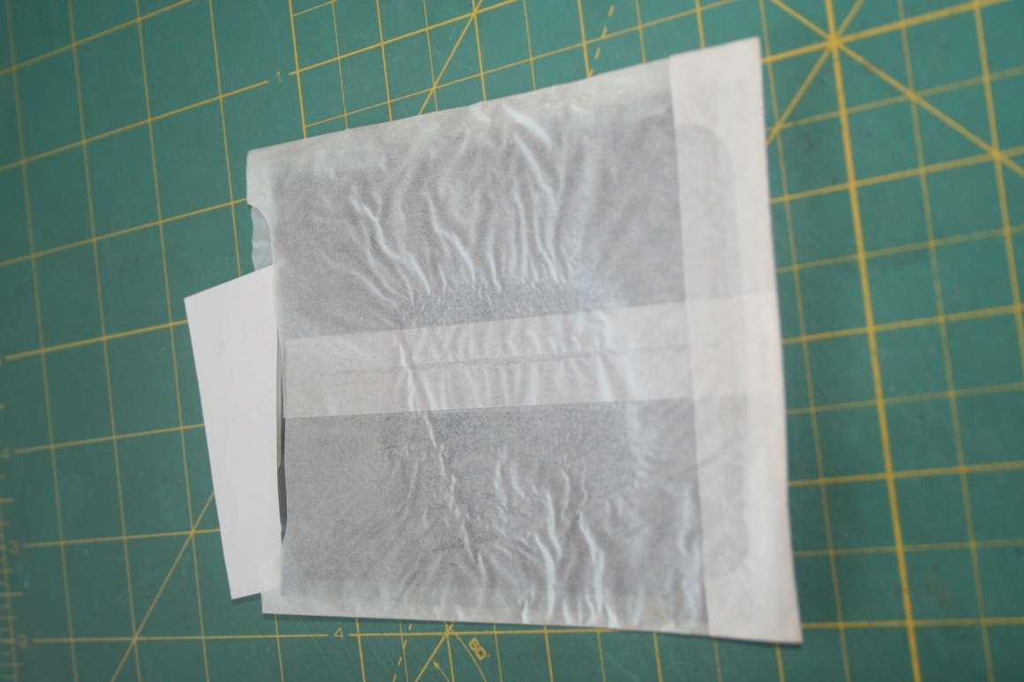
Some of the black and white 4x3 negatives had also become stuck to the waxed paper envelopes, however looking at them under a glass suggested that there was no damage to the actual negative, it was just stuck.

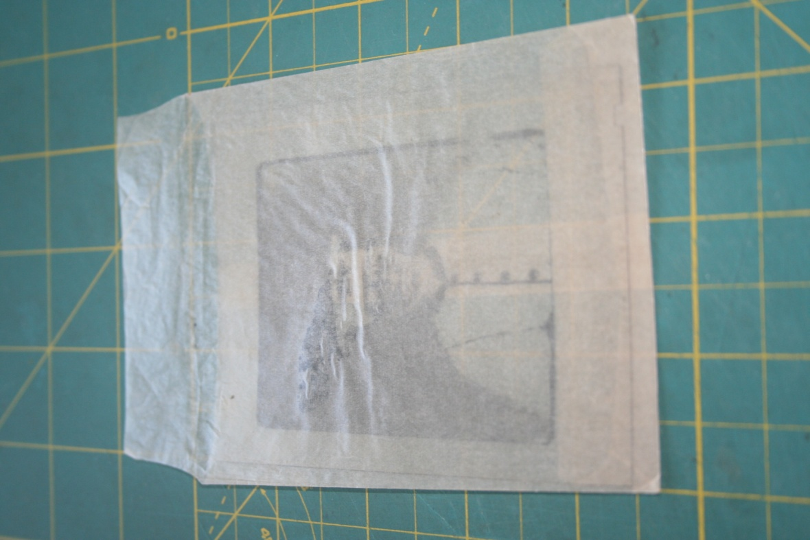
This photograph is from Grimsby and is in a different type of wax paper bag. You can see the rippling in the paper and also some areas where the dark emulsion appears to have attached to and bled into the wax paper. Obviously a more serious problem to deal with.

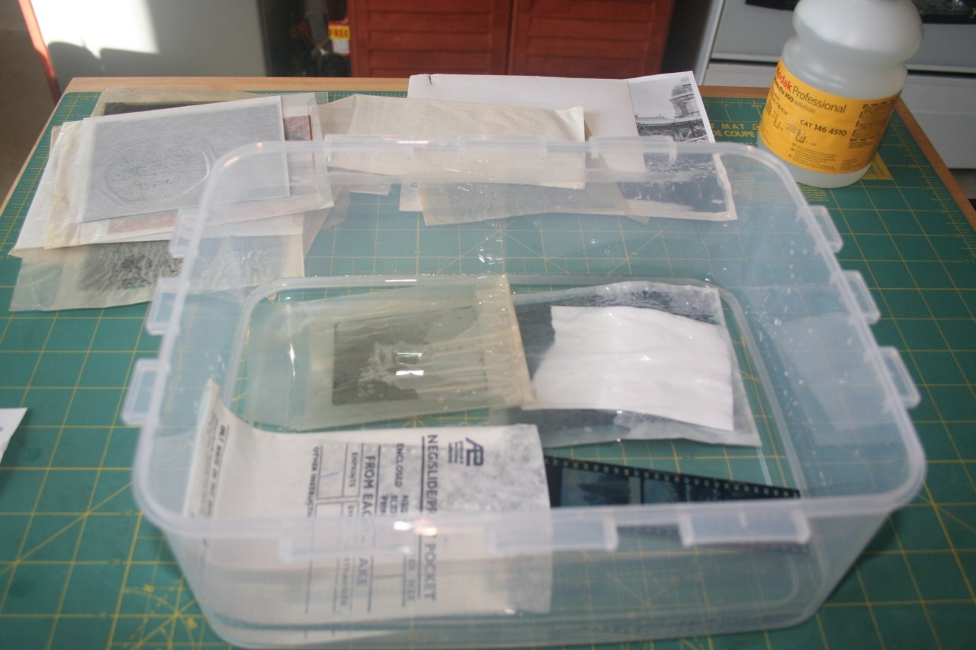
With help and advice from the http://photo.net/digital-darkroom-forum/ web photo forum, I was able to track some Kodak Professional photo-flow down. This a wetting agent. It makes water wetter! There is less chance of water globules sticking to film. So with a small photo bath (a large plastic sandwich box from the local supermarket), some distilled water from the police dental clinic, the only place I could get any (warmed following Kodak instructions) and Kodak Photoflow. I went to work.
The colour strip film was the easiest. The paper bag disintegrated in seconds and the film strip came away without problem. I rinsed the film in a clean bath of the wet water, then used a photo squeegee to remove most of the water before hanging it up to dry.

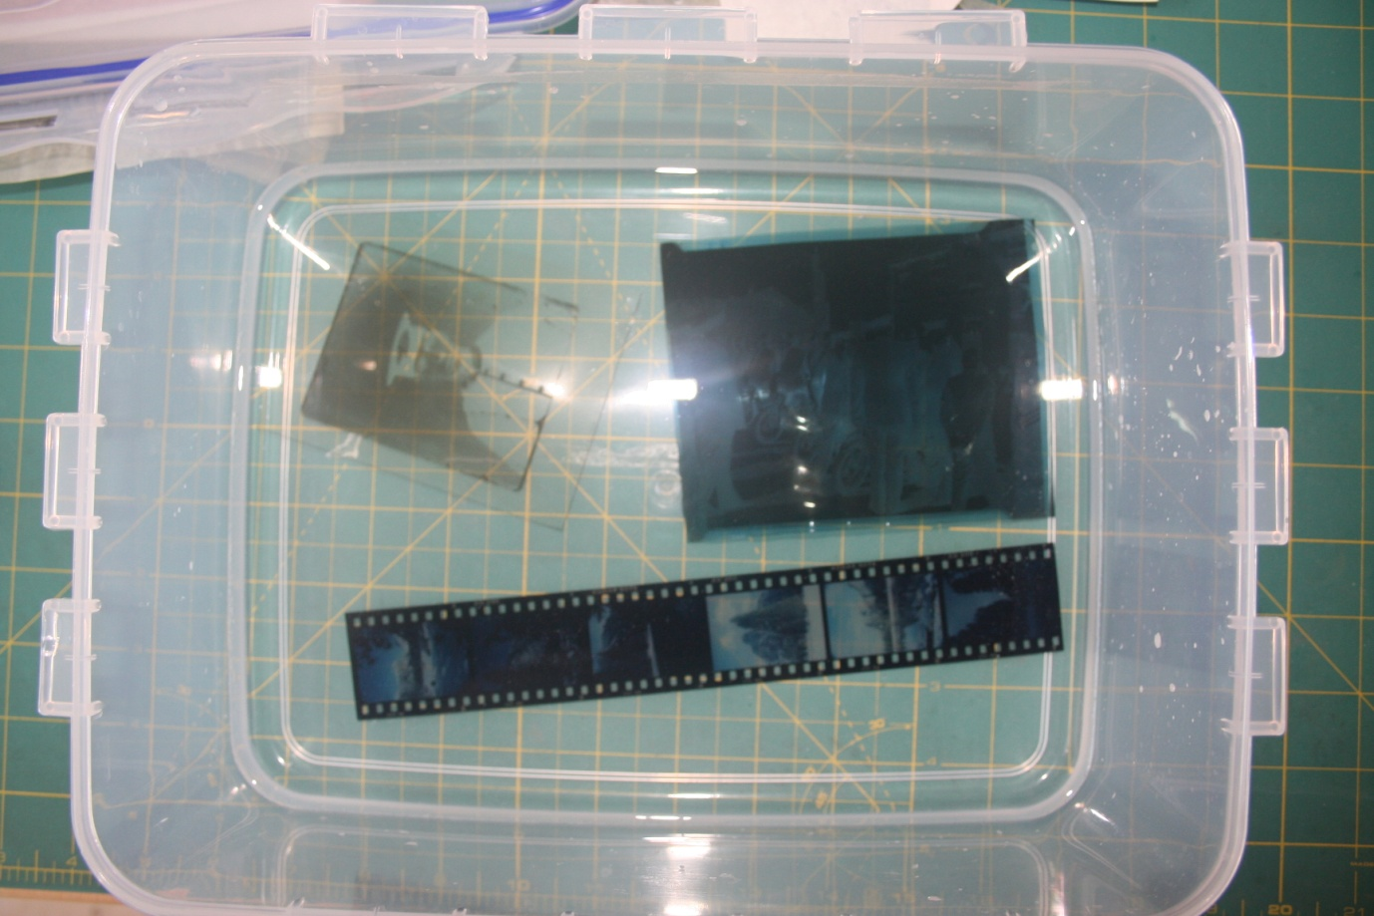
The other two bags began to disintegrate after around one and a half minutes and I very carefully peeled away the wax paper. The negatives were in the water no more than 3 minutes.

In both cases, there was no damage to the negative, and like the colour film strip, after a rinse in clean wet water, they were carefully hung up to dry.

In the dim and distant past I completed a black and white photography course at the Durham Constabulary Scenes of Crime school at Sedgefield, under the irascible Detective Sergeant Price, so I have some familiarity with black and white film processing. I also know about the Mould which attacks organic material, specifically the cellulose in the film that the emulsion (the bit you see) sits on. However the damage did not look like anything I had encountered before and it was only on a tiny number of negatives that I could identify as having come from one lab. Active Mould is usually black, inactive mould is white and powdery. Mould spreads by spores and these are everywhere in our environment, however it requires specific conditions for the spores to germinate, a temperature of +68°f / +20°c, and a relative humidity of 70% or more.
As all my photo negatives in particular had been stored in museum archive boxes, in individual envelopes, and with desiccant packets in the boxes, the resulting low humidity was unlikely to allow the germination of Mould and it didn’t look like a growth.
What I discovered was that although the film base of these early 1950’s photographs is cellulose acetate, the thin, adhesive layer binding the base to the gelatine emulsion is cellulose nitrate. When this type of early negative is stored in warm ambient temperatures (and I have lived in several places with “warm ambient temperatures”), deterioration can occur. The base shrinks and separates from the emulsion in channels, creating random ripples in the film. Nitrate dioxide in the middle layer combines with residual moisture to form nitric acid, and gas bubbles form that are trapped between base and emulsion layers.
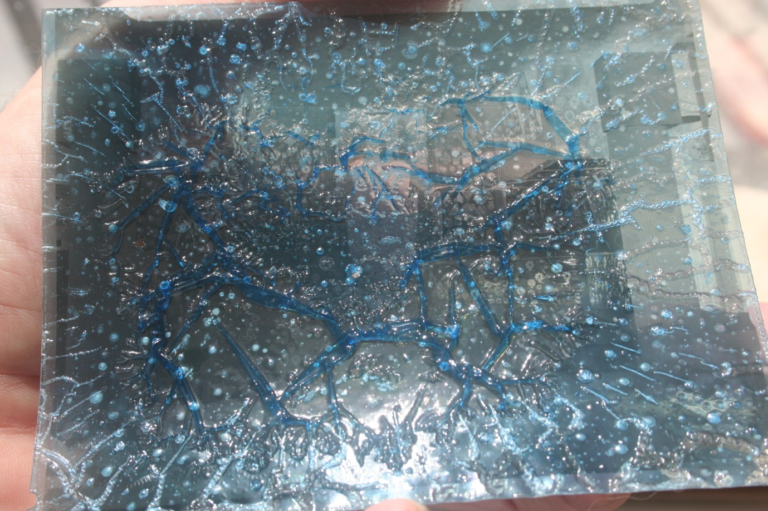
Another possible cause of damage to old negatives is what is sometimes called the “vinegar syndrome.” http://en.wikipedia.org/wiki/Cellulose_acetate_film This term is applied to a type of deterioration found in acetate and triacetate safety film. When cellulose acetate replaced cellulose nitrate as a film base for safety reasons around 1951, it was thought that the acetate base would also be less vulnerable to deterioration.
But within a very short period of time, reports from India suggested that this new film was deteriorating very quickly. In the 1980’s there was intensive scientific research into obvious film base deterioration and the accompanying characteristic smell of vinegar. Essentially, the chemical reaction that created cellulose triacetate from cellulose and acetic acid occurs in reverse (deacetylation). By hydrolysis, acetate reacts with moisture to form acetic acid with its identifiable vinegar smell. Once this reaction starts, it cannot be stopped, and in fact, speeds up. Besides damaging the base, the acid can cause deterioration of the image as well.
There is often a bluing visible. Several of my photographs showed this, and the blue film became even more visible when they were placed, even briefly, in the water bath.
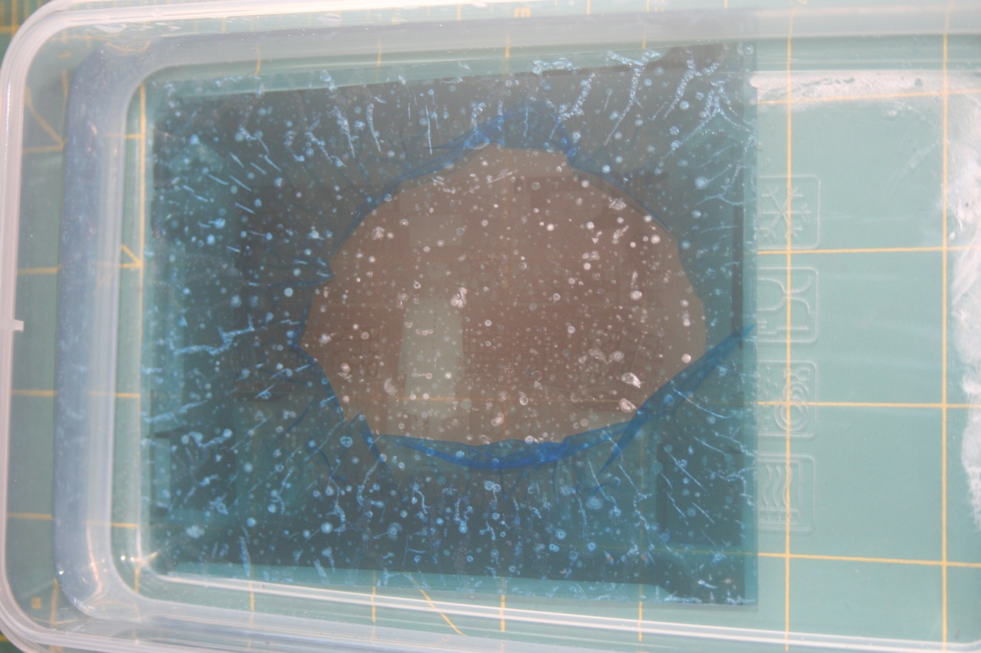
It is essential to stabilise the negatives and slow deterioration by lowering the ambient temperature. Current best practice involves placing affected negatives in acid-free envelopes and boxes and keeping them in a cool environment. To further extend the life of the film, a “molecular sieve” – small bags of desiccant crystals, are included to absorb moisture and acetic acid.
There was no real smell of anything from my photographs, but the damage was clear. The storage bags from Grimsby soaked up water like a sponge in the wash bath, and I suspect that they have absorbed some humidity and touching the negative have started “vinegar syndrome”. Further research showed a website with a negative that looked like mine did. http://gawainweaver.com/news/vinegar-syndrome/ I am 90% certain this is what happened to my negatives.
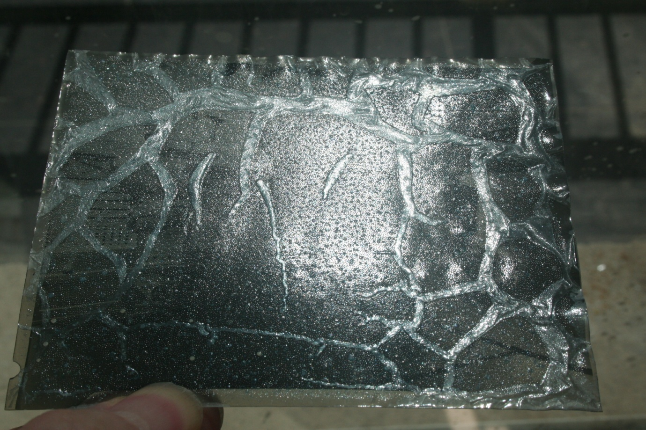
In the bath, it was possible to remove the blue film, but where a tiny microdot of image had been lifted and had stuck to the paper bag, the image remained damaged. Once out of the bath, the images dried very curled, no matter how I tried to prevent it.
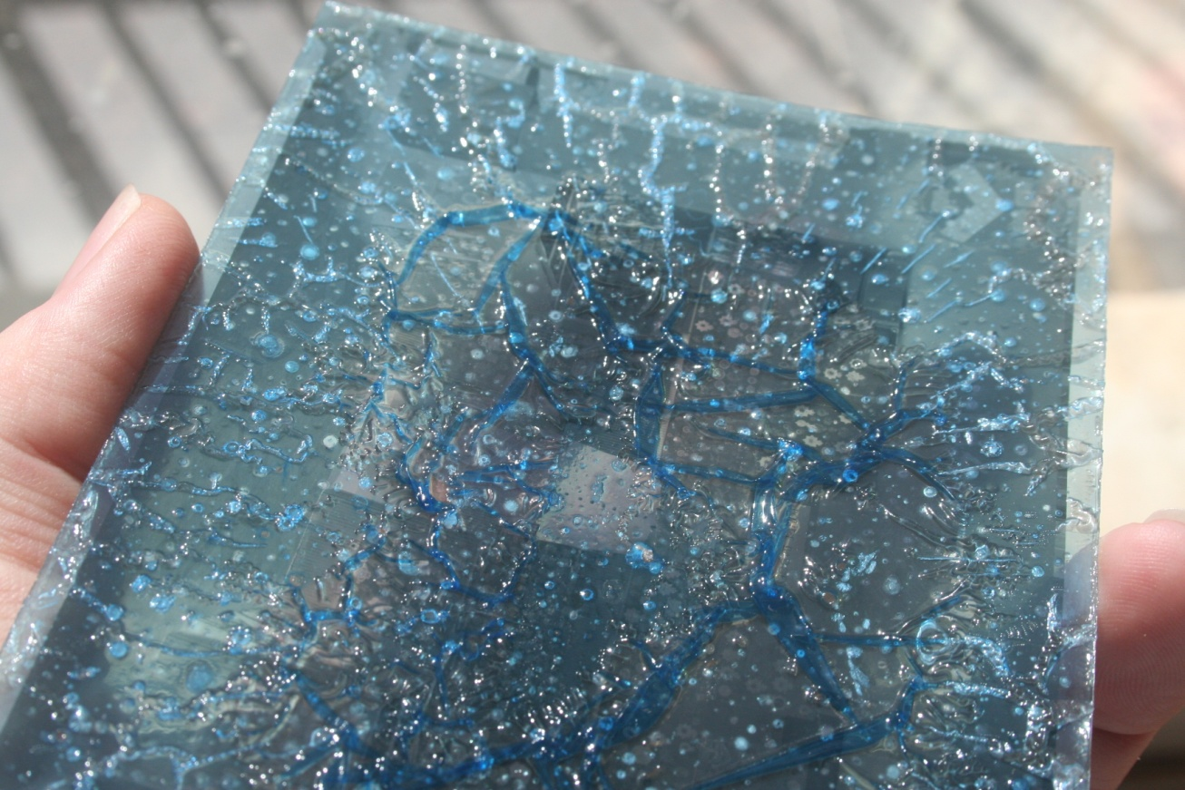
I remembered a technique I had once been shown of how to scan a wet negative between glass. This is what is known as Fluid Mounting or Wet Mounting http://scanscience.com/ . I don’t have the right equipment on my scanner, but fabricated a DIY wet scan bath by laying thick kitchen cooking “cling film” on the platen, then the wet negative, straight from the bath, then a small piece of glass. This at least allowed me to scan the negatives.
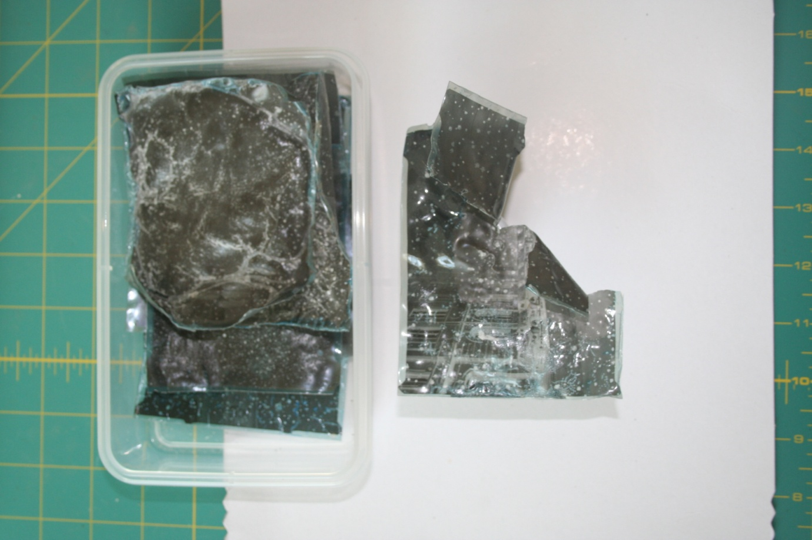
Once dried, the negatives are damaged beyond repair. In all, I have lost 10 negatives, but have been able to scan the images by wet scanning, although most have extensive damage.
The bottom negative is the one I will use as an example of what can be achieved.
I have no “Before and After” photos because the images were stuck to the bags and I had only a short space of time from soaking to remove the bags and scanning, before the curling began.
This is the image, taken in Grimsby, outside the then Town Hall, in what is still called Town Hall Square (Google StreetView link http://goo.gl/TSlGfO ) looking ENE. It was not taken before September 1954 (the Month EJV 709 was registered) and looking at the light and the angle of the sun, shadow lengths etc, it is probably October or November.

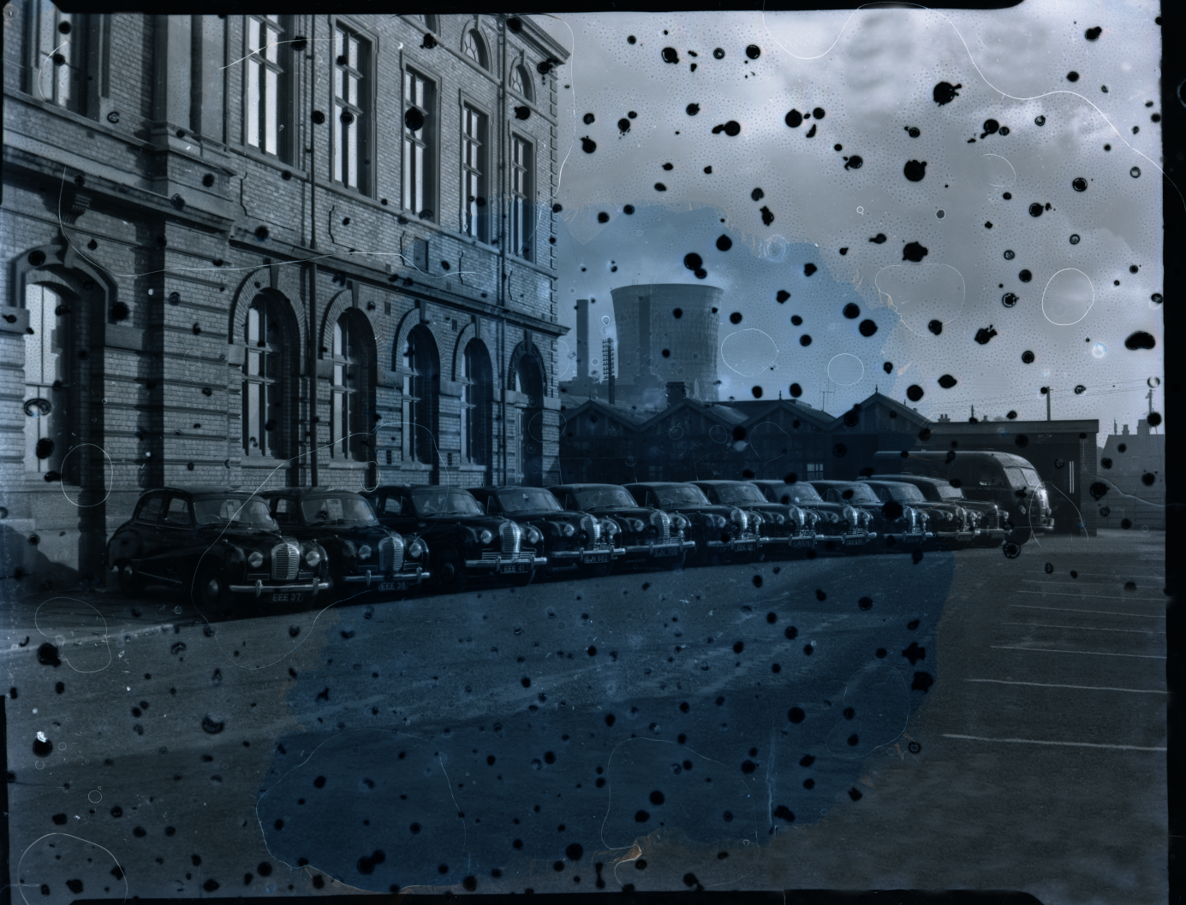
The is the negative, as scanned using the wet process. Each black blob is where part of the emulsion has lifted away and the detail has been destroyed. The scanner converts the negative to a positive image.
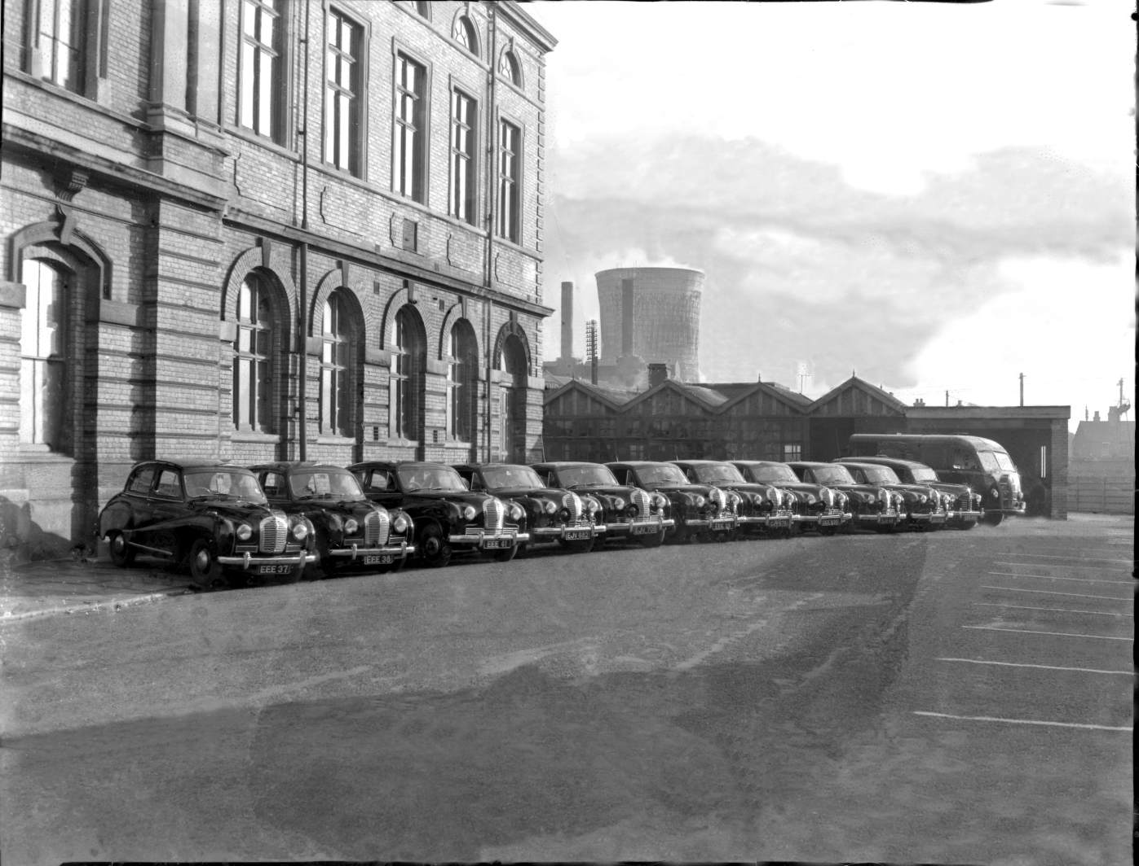
After around 8 hours work in Photoshop, this is the result. The sky is not right, but it is not difficult to drop in a new sky background, however most of the other detail has been preserved. This could be printed at 10x8, but much larger and the repairs will start to stand out. More work is needed to finish restoration, but it provides an example of what can be achieved at home, from a severely damaged 5x4 negative.
The moral of the story? Scan all your negatives while you can and they are undamaged. Damage can be repaired later, but the end product will never be quite as good.

You’ve scanned the negative, now what?
There is often latent information in a negative that was never printed. Anyone who has worked in a dark room will remember the old dodge-and-burn technique to enhance a certain part of a printed photo and to reduce (darken) another area. When you scan a negative, or remove a photograph from a frame and then view the digital result, you may find there is more photographic information that you didn’t know about. Some edge detail may have been hidden by the frame, or simply the high resolution scanning sees details too small for the naked eye. Most old photographs and negatives are in pin-sharp focus.
Knowing the hoops that are now gone though to ensure the digital integrity of an original digital police image, and then showing changes and enhancements that are made, I wonder how in the past we got away in court with enhanced prints? The answer is of course in the statement that the photographer made that he had the made the prints and he had the negatives in his possession. I am not aware ever that the defence asked for the negatives to make their own prints from!
Digitised images may be improved in appearance by tweaking contrast, intensity etc. and removing minor surface marks. Digital copying also allows considerably enhanced access by users (like PMCC) for research, exhibits, publication and enjoyment. Importantly, images made available through the Internet may be accessed remotely by researchers and users anywhere there is connectivity, thus revolutionising historical and genealogical research.
The downside of “digital preservation” is not quite as obvious. What was once promised to be the ultimate process for extending the life of archive material indefinitely, is now realised not to be the case. You may have already discovered that individual digital files can be corrupted, disks, even when kept in perfect conditions, may become unreadable and that the technology for reading a particular format can rapidly become obsolete.
CD’s and DVD’s which were originally thought to be almost indestructible, are adversely affected by oxidation, stray magnetic fields, humidity and decomposition. Without vintage equipment, some audio and video media files are unplayable, e.g. 8-track audio tapes, Betamax format video cassettes. I have around 50 SVHS tapes which I can no longer play at SVHS quality Even computer files may need obsolete equipment and software to be readable, e.g. 5 ¼” floppy and 3 ½” Magneto Optical disks. I can no longer read half a dozen 5 ¼ floppy disks, which are to destined to remain museum pieces in themselves. But I know there is no valuable data on them.
As a practice, I save digital images in several formats, depending upon the kind of source material. Paper documents are saved as Photoshop .psd and lossless TIFF files. Negatives as .psd and .png. The Photoshop .psd format has been around for a while, and is backwards compatible, but for how long? Papers can be scanned and saved in Adobe Acrobat Portable Document Format (.PDF), however everyone needs to be mindful that at some point you may have data which you cannot read.
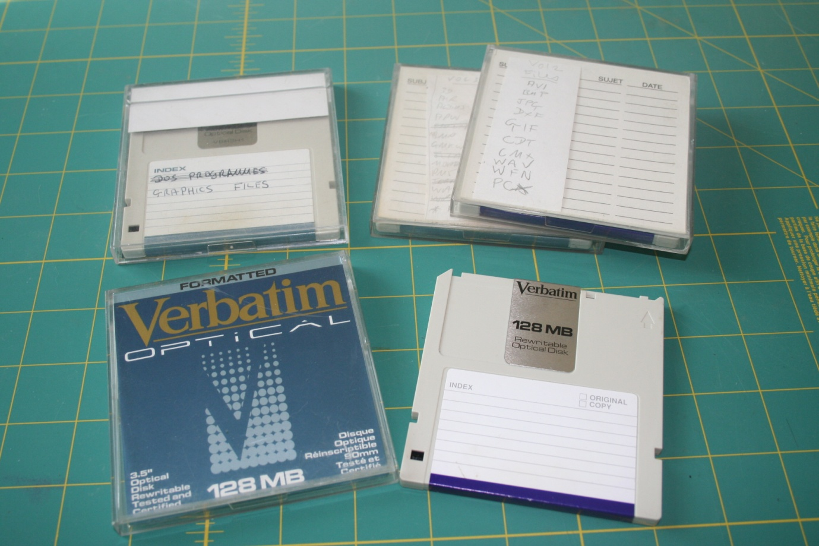
I have several of these 3 ½ inch MO disks from the late 1980’s and early 1990’s, but my only drive to read them no longer works and I cannot even find one on eBay. I have no idea what these disks contain, but my paper tabs indicate there are old files and my first digital photographs on them.
Professional archivists recommend that as well as any digital file, negatives and photographs are printed using stable ink on archival lignin and acid-free paper. It is thought that this will have the greatest chance of the material lasting, providing the resulting photograph is also appropriately stored. This is beyond the scope of all but the most specialised photo labs, and the cost is beyond the reach of most individuals, so we are left with the question of what should we, as individuals do?
The answer is, as much as you can yourself. Scan photos and negatives. Save each item as a different lossless format, back up digital files to two different makes of media. I am still using CD’s from the early 1990’s, whereas some DVD’s purchased in 2006/2007 have failed. I have never bothered with Blue-Ray, because I fear the loss of data on such a singularly large and expensive disk.
Don’t forget the online storage, using websites like the one run by PMCC member Alan Matthews at http://www.flickr.com/groups/1510613@N22/ There is less chance that a photo lodged with an online website will be lost forever, but it can happen.
And when you have done all that, make a couple of security copies of the digital files and send them to friends to keep. If you have the ultimate disaster at home, at least someone else will have a copy!

Back to my damaged negatives!
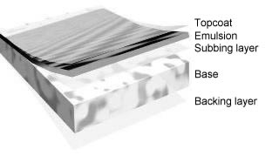
I will mention briefly the construction of a black and white negative. If you know, or don’t need to know this, please skip ahead. This is a generalised description because there are slight differences between manufacturers. The Australian National Film and Sound Archive has a digital book with detailed descriptions of many different elements of preservation, from where the above graphic came. http://www.nfsa.gov.au/preservation/handbook/ It’s worth the read.
Film is basically a light sensitive emulsion on a gelatine (plastic) base. There are generally 5 layers, of varying thicknesses, in a black and white negative (what is generally called the ‘film’ that was in the camera when the photograph was taken).
1. The Overcoating protects the film from friction, scratches, or abrasions before it is developed. The overcoating is a clear, gelatine layer that is sometimes called the anti-abrasion layer.
2. Next is a thin Emulsion layer of gelatine that suspends and supports the light-sensitive silver halides.
3. Base-This supports or holds the emulsion in place. The base may be transparent, translucent, or opaque, depending upon how the recorded image is to be used. The base is generally made of a cellulose acetate.
4. The Antihalation Backing prevents light from reflecting from the base back into the emulsion. The antihalation dye is sometimes incorporated in the anticurl backing. The dye used to eliminate halation is a colour to which the emulsion is least sensitive. This dye is water soluble and is completely dissolved and flushed away during processing.
5. The Noncurl Coating is a hardened gelatine, about the same thickness as the emulsion, and is applied to the back of the film. A film emulsion swells when wet and shrinks when dry. This contraction produces a strain on a film base because it is highly flexible. The noncurl coating prevents the film from curling during the drying process.

Scanning
Scanning documents, photos, anything in fact, is often portrayed as a “black art”, especially by those people who do it for a living. It isn’t. But you do need to know the principles to make successful scans.
There are many types of scanner – I have 4 that are for different purposes in my study at home – but the average home scanner now is capable of 10 or 20 times better finished images when compared to early model top-of-the-range home scanners.
Scanners may just have a flat platen where the item to be scanned is placed, or they may have a slide or photo adaptor with a lamp in the lid as well. They may be made just for scanning slides or film strips, or for papers. The most expensive and highest resolution scanners are drum scanners, but no one is likely to have one of these at home.
Keep the glass plate (platen) of your scanner clean, absolutely clean. I have a blue window cleaner spray bottle and some paper towels by mine and clean the glass before starting, and after every half a dozen or so lid openings. Static electricity attracts dust (and cat hairs) to the glass.
I use a Fujitsu 6130f document scanner. It will batch scan 150 pages in one go, both sides. However, scanning at 300dpi makes a very readable document by eye, but optical character recognition (OCR), a key part of saving documents so you can search for content, has very low accuracy.
By trial and error, I have found that by scanning at 600dpi, in 16 bit colour, the accuracy of the OCR of black and white papers reaches 99%. Scan at the highest resolution you can.

Software
I have Adobe Photoshop 7 and use that as my primary programme for saving and restoring photographs. I have used Photoshop since it came on 4 floppy disks. I also have Corel Draw 10, which includes Corel PhotoPaint.
Scanners usually come with a selection of software for scanning and photo manipulation and there are some extremely good free programmes available on the web. Upgrading software over the years has not been too expensive, but I am aware of just how much Photoshop now costs as a new buy.
I use Silverfast, which came bundled with my Canon Canoscan 9000F film scanner, as the specialist software interface between the scanner and Photoshop. I find it better than the Canon software, but again, don’t get hung up on one particular piece of software.
I am not going to discuss specific Photoshop techniques, because they are all available on the web, and if you use a different software, my technique will be irrelevant. Instead I will explain the way I have gone about the restoration tasks and leave it up to you how you use your own hardware and software to achieve the same result.

The Face at the window - When do you “leave well alone”?
Good question. The earliest photograph I have, is also perhaps the most damaged. This photograph shows the yard at the rear of the Sessions House in Beverley, c1855. The Sessions House became the headquarters of the East Riding Constabulary in 1856. The photograph shows the East Riding Reformatory and Workhouse, sadly the Treadmill is not in the image. Alfred Shepherd was the governor of the prison from 1845 until its closure in 1877. He is believed to be the man in uniform in the photograph on the left.
I suspect that the gentleman with the white hat, leaning nonchalantly on the hand cart might be the Chairman of the Quarter Sessions Court, which had oversight of the Reformatory. The taking of a photograph in 1850’s Beverley would have been a momentous event.
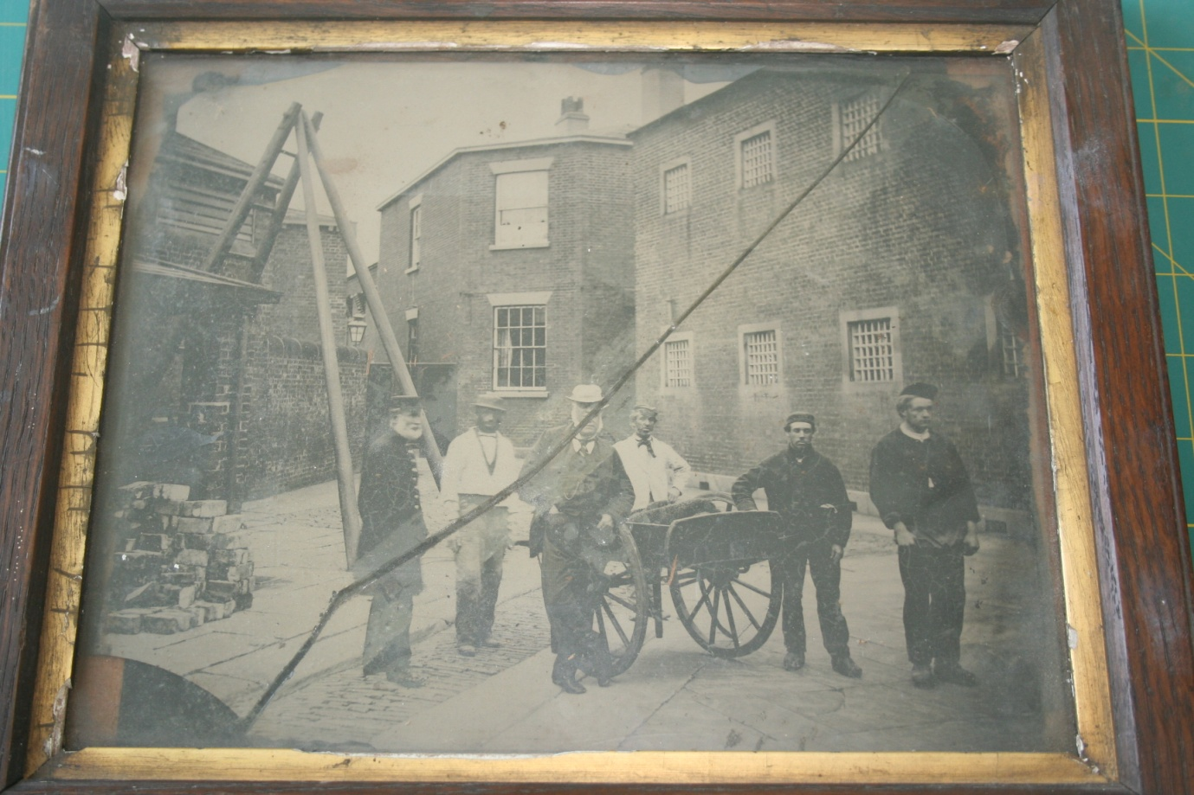
This is a Google Maps and Streetview link.
http://goo.gl/LVqYzV Click on the link, then when Google Maps opens, click on Street View. The workhouse is the tall, thin red brick building, behind the police vans.
The building on the right in the photograph with the barred windows is the reformatory, still used by the police and still known today as the Convent. After the reformatory closed, it was converted into a convent. before being sold to the East Riding Constabulary.
This is almost as I was given the photograph. I say almost because it came wrapped in a 1950’s plastic material, that had discoloured and become brittle. The photograph is cracked and has slipped, there is one corner missing and judging from the position of the eyes and rings on the back, this is not the original frame, as the eyes are positioned to hang the frame in portrait not landscape fashion. The solid wood back support has dried and separated along the grain too. This type of backing was used before plywood. Then there are the rusty one inch Brad nails that hold it all together!
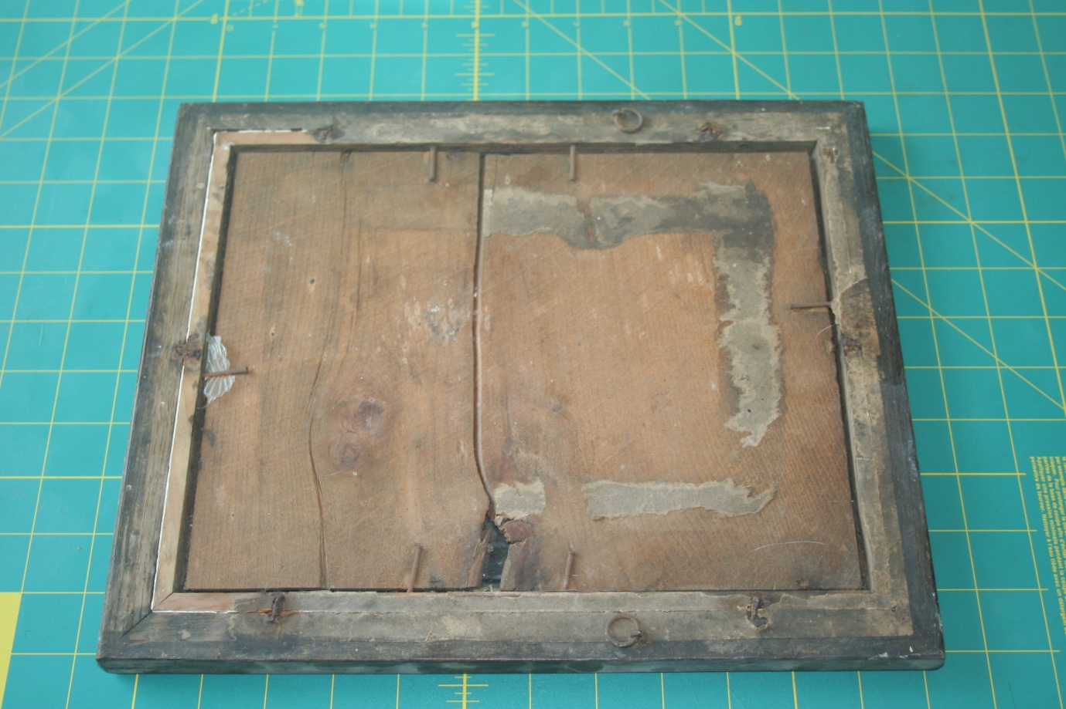
I tried with early scanners I owned to copy the photograph, as I did not want to disturb it, but reflective scanning, because of the distance from the plate scanner to the photograph, failed due to the frame depth. A digital photograph worked to a degree, but restoration in Photoshop proved difficult.
With a little more time now and modern scanning technology, I decided to very gently try and remove the photo from the frame and see what could be done to restore it. This really is the last resort, but I felt sufficiently confident in my skills that I could at least try and make it better, if not restore it.

The workflow
I like to use a large cutting mat on my desk. This allows for small things that may come out of a restoration project, not to get lost.
First of all, get the right tools for the job. In this case a pair of curved needle nose pliers to gently remove the 6 rusting Brad nails from the rear. I put them to one side, as I wanted to replace them into the frame when I had finished, for historical accuracy.
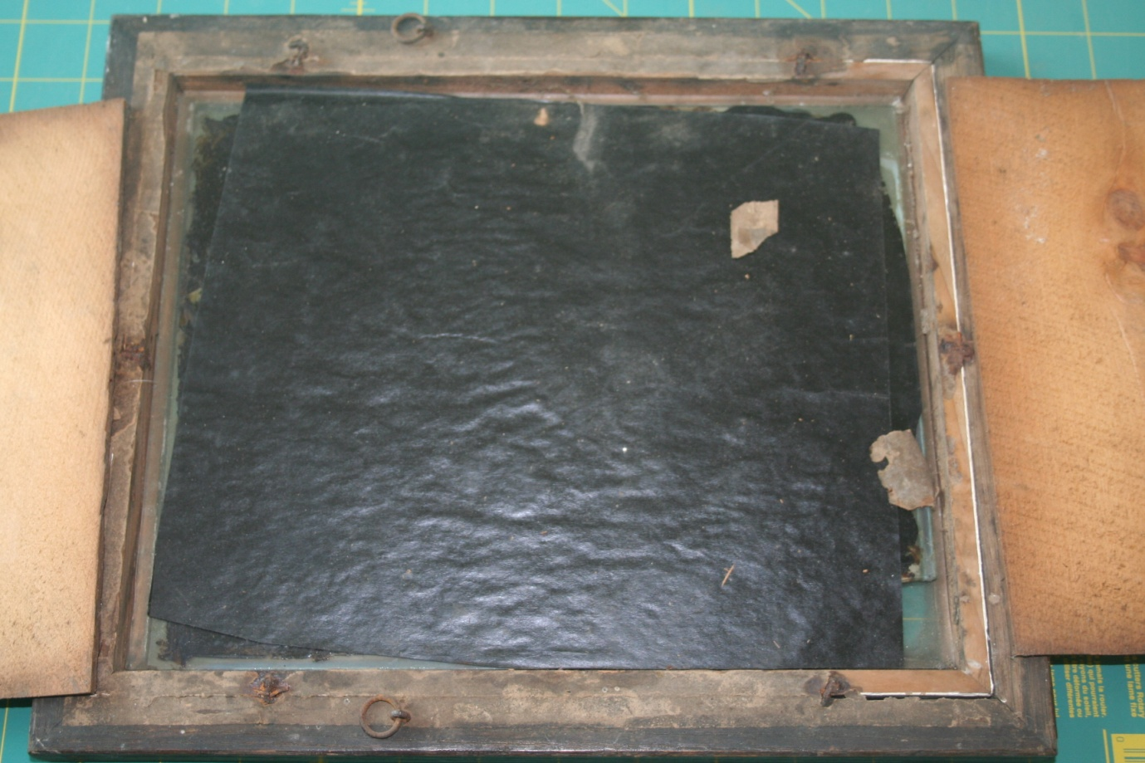
With the nails removed, the two pieces of wood back easily lift out. Nothing was attached to them.
Behind them there is a piece of thin glossy black paper. I gently peeled this away in case it was sticking to anything. It wasn’t. But what also came away were two pieces of pressure sensitive adhesive tape, both with what I thought were elements of the image attached. In the UK, much of Europe and the former Colonies , this tape is known as Sellotape once a trade name, now a generic term, in the Americas and elsewhere it is known as Scotch tape. The broken corner was not present, something else lost in the mists of time. I carefully put the adhesive tape to one side.
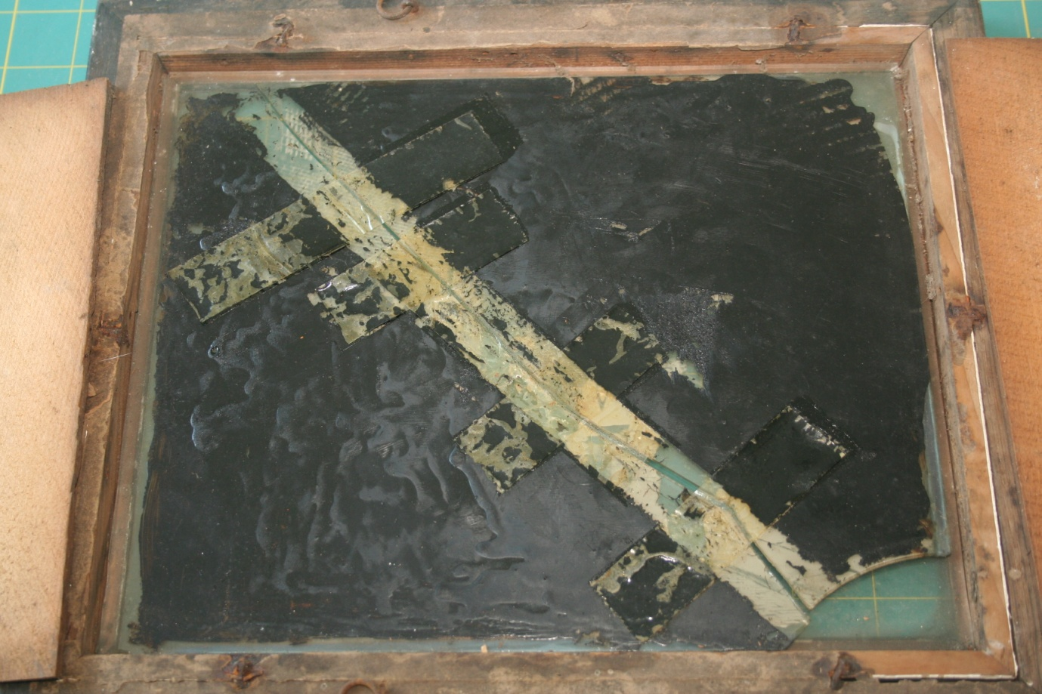
Now I can see the back of the photograph clearly for the first time. It has been painted with a layer of black lacquer of some kind. This immediately made me think that I am dealing with a very old type of glass negative. The negative is fixed onto glass and it is light reflected off the black back that makes it visible. It was probably taken between 1853 and 1865 using the wet Collodion process and is an Ambrotype. http://en.wikipedia.org/wiki/Ambrotype The early Ambrotype photographs had black glass fixed to the glass negative. This photograph has a black painted backing to the negative, probably Black Japanning, http://en.wikipedia.org/wiki/Japanning , a common process used in the mid 19th century.
Because of the difficulties of practical photography using the wet process, by the early 1860’s it was being replaced by newer, less difficult dry plate photographic techniques for photographers. The individuals dress in the photograph suggests the mid to late 1850’s and that is as close as I can get to an accurate date
This is a good website to help you identify the type of very old photographs you might have : http://www.cycleback.com/photoguide/dags.html
There had been an amateur attempt at some time to repair the photograph by trying to hold it together with a long line of adhesive tape along the length of the crack and four pieces across the crack. This adhesive tape had dried out completely, but not before lifting away the black backing of the photograph. However because it is an Ambrotype, it has not destroyed the negative image, which is on the front.
My next concern was that the glass plate that held the negative would be stuck to the glass of the picture frame. First I needed to get the two pieces of glass out of the frame. Lifting the frame off the cutting mat I gently eased the front glass back, keeping the two pieces of glass level. It came away without a problem and I was able to lift both out and slide a piece of thick card under the front of the glass to act as support and a means of lifting it, without a problem. I carefully measured the negative glass – precisely 10 inches by 8 inches. Next I cut a 10” x 8” piece of black art cartridge paper, and put it across the back of the negative glass, with the remaining adhesive tape underneath.
With a pair of rounded tweezers (ex-eyebrow tweezers, courtesy of the Domestic Gold Commander) I lifted the smaller of the glass pieces, it came away without a problem. Nothing was stuck to the front glass, so I tried the same with the larger piece. It also was not stuck. With a piece of card on the back, I sandwiched the two pieces of glass and inverted them, before lifting away the front glass.
It was filthy on both sides, another reason my first attempts at scanning failed.. There was a well defined rectangle in the centre, where the previous picture had been, so clearly when the frame was reused, there was no attempt made to clean the glass! The glass appears to be 19th century and has a couple of manufacturing flaws in it. So the frame is a similar age to the photograph, but is not the original one used.
The next stage was to clean the front of the Ambrotype. It always helps to understand what you are dealing with. This Ambrotype glass negative was made in a wet process consisting of several stages. A scrupulously clean glass plate was covered with a thin layer of Collodian before being dipped in a solution of silver nitrate and placed in the camera, still wet. The negative was then exposed for anywhere between 10 and 60 seconds before being developed and fixed. You can see the prison governor is indistinct as he has moved while the shutter was open.
I have never cleaned one of these before, and I could find no advice on the internet. Logic says, don’t use chemicals or solvents, so it is back to one of two options, de-ionised water, or distilled water. I decided to try the latter first. Always, always try a small corner first when you try and repair something, where if there is any damage it will not be seen. With a cotton bud dipped in distilled water I cleaned a small corner. It came away very brown, but not black and I could see underneath that the negative was visible. So very gingerly I tried a larger area. It was also filthy but immediately detail that was not visible before could be seen. With a soft lint free cloth soaked in distilled water, I cleaned all of the front of the Ambrotype, changing the cloth regularly so as not to scratch the surface of the negative..
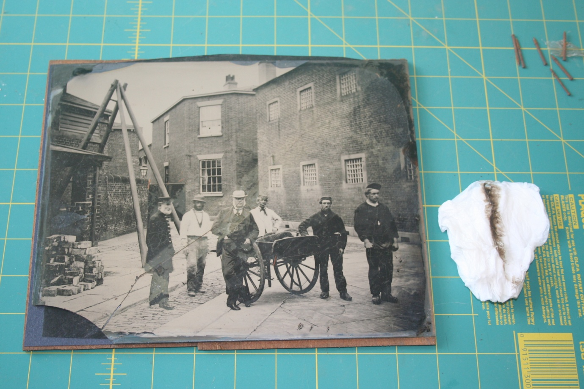
When held against the light, the layers of chemicals that were swilled across the surface of the glass, some 160 years ago, are clearly visible.
Although the negative seems quite strong, to prevent finger prints, I only ever handle negatives, and especially glass prints, wearing white cotton gloves. I also use the gloves when I am scanning film.
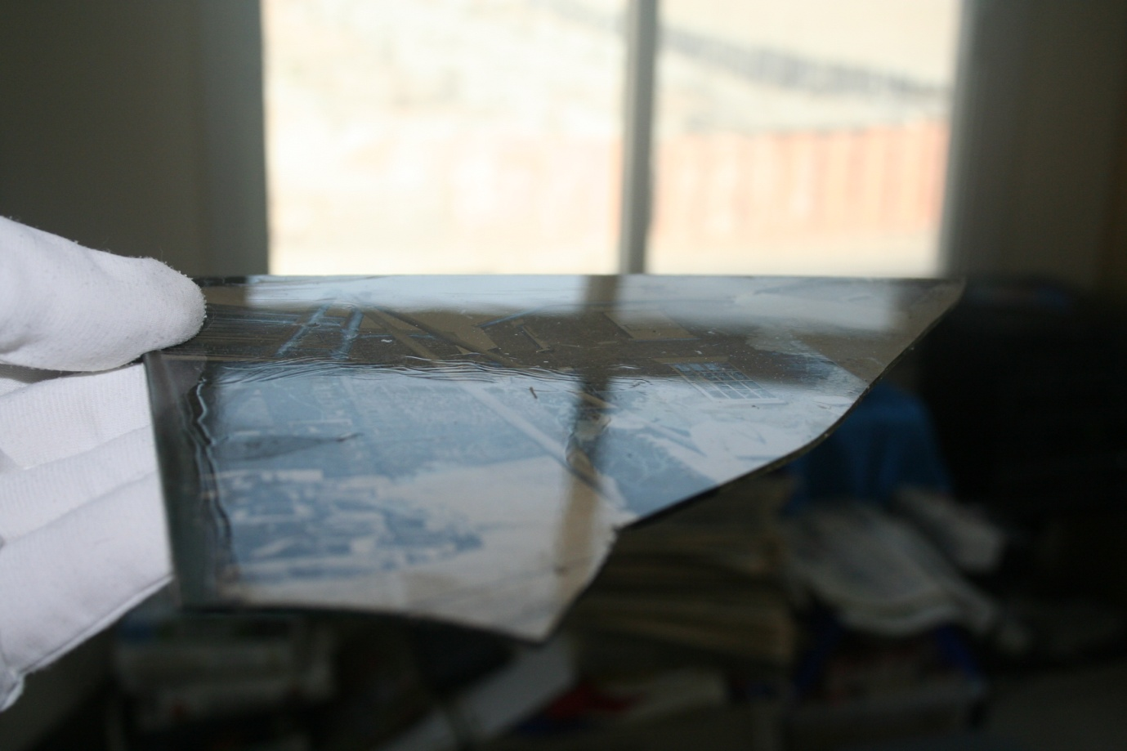
Scanning and restoration
After cleaning the scanner platen, I gently positioned the two sections of Ambrotype negative on the scanner. I had considered scanning in two section, the two halves, but I thought as a first try, I would line them up and scan in one single pass.
I set my scanning software to 600 dpi (dots per inch), which would give an output file size of 256 megabytes. I would liked to have scanned at 800 dpi, but the resulting file would be over 1 gigabyte. I scan in 28 bit colour, with autosharpen enabled. After the pre-scan, I adjusted the brightness up and the contrast down, then scanned.
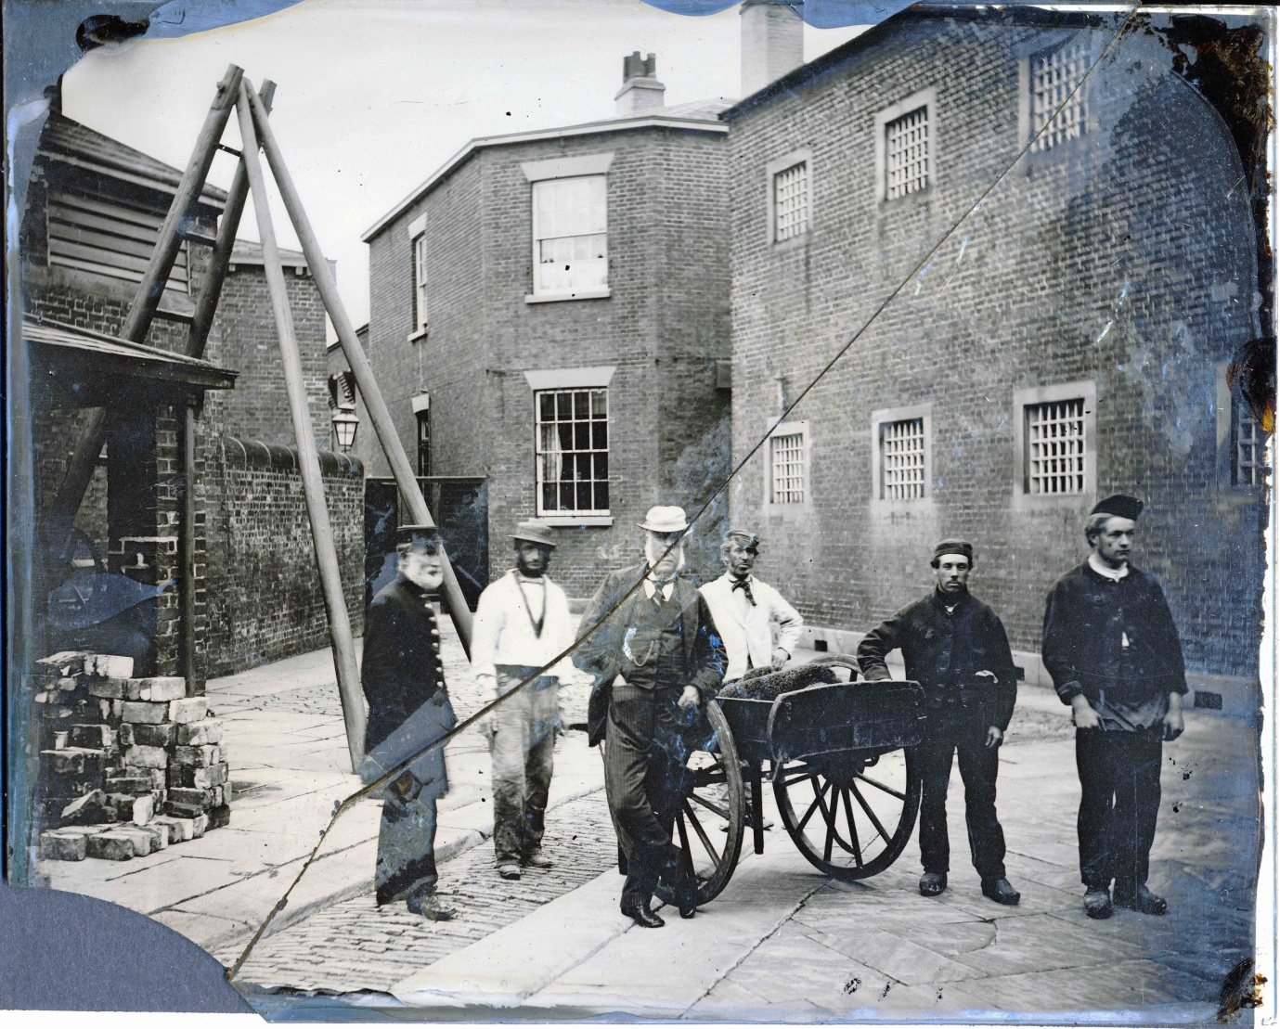
The result was OK, but even though I had used black art paper, there was a very distinct mark where the adhesive tape had been, along the length of the crack and the pieces at right angles. Next I tried a scan with a dense black glossy photo paper. This was created on a laser printer, set to print a text box of 100% black on photo paper. The image was better but still not good. I wondered about replacing the black japanning, so first I tried a small corner of the back with a black spirit marker. The improvement was dramatic. Just to make sure, I used the black marker on the Frock Coat and trousers area of the prison governor. The results speak for themselves.
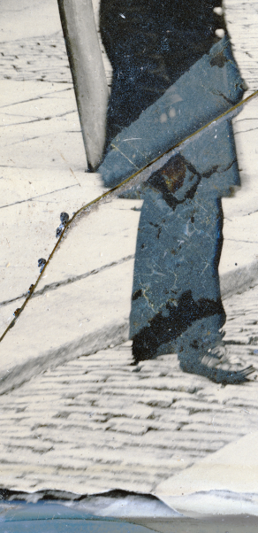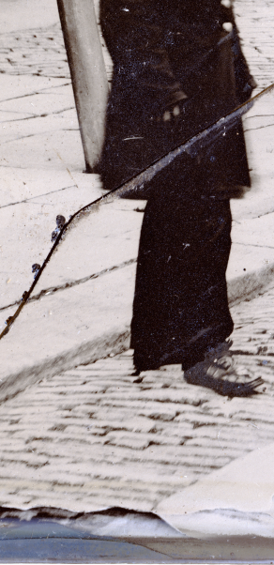
More research followed into what I should use to repair the backing. The Institute of Museum and Library services in the US hosts a detailed page on old photograph conservation http://notesonphotographs.org/index.php?title=Whitman,_Katharine._Case_study_7:_1/2_plate,_pass%C3%A9-partout_style_ambrotype_with_backing_losses My being in the Middle East, where most things are difficult to come by, told me that shellac in methylated spirits was going to be next to impossible, so I visited my local craft store and obtained some Marabu glass paint http://www.marabu.de/kreativ/produkt/ansicht/?pid=130239473 , a specialist spirit based paint designed for glass, . Rather than try and remove the old black varnish, I decided to very carefully replace the missing areas after first removing any lifting varnish. The picture was then rescanned at the same settings.
Placing the glass face down, on soft lint, on a light table helped identify large and small areas where the Japanning was missing. This is before, where the missing and light areas are clearly visible:
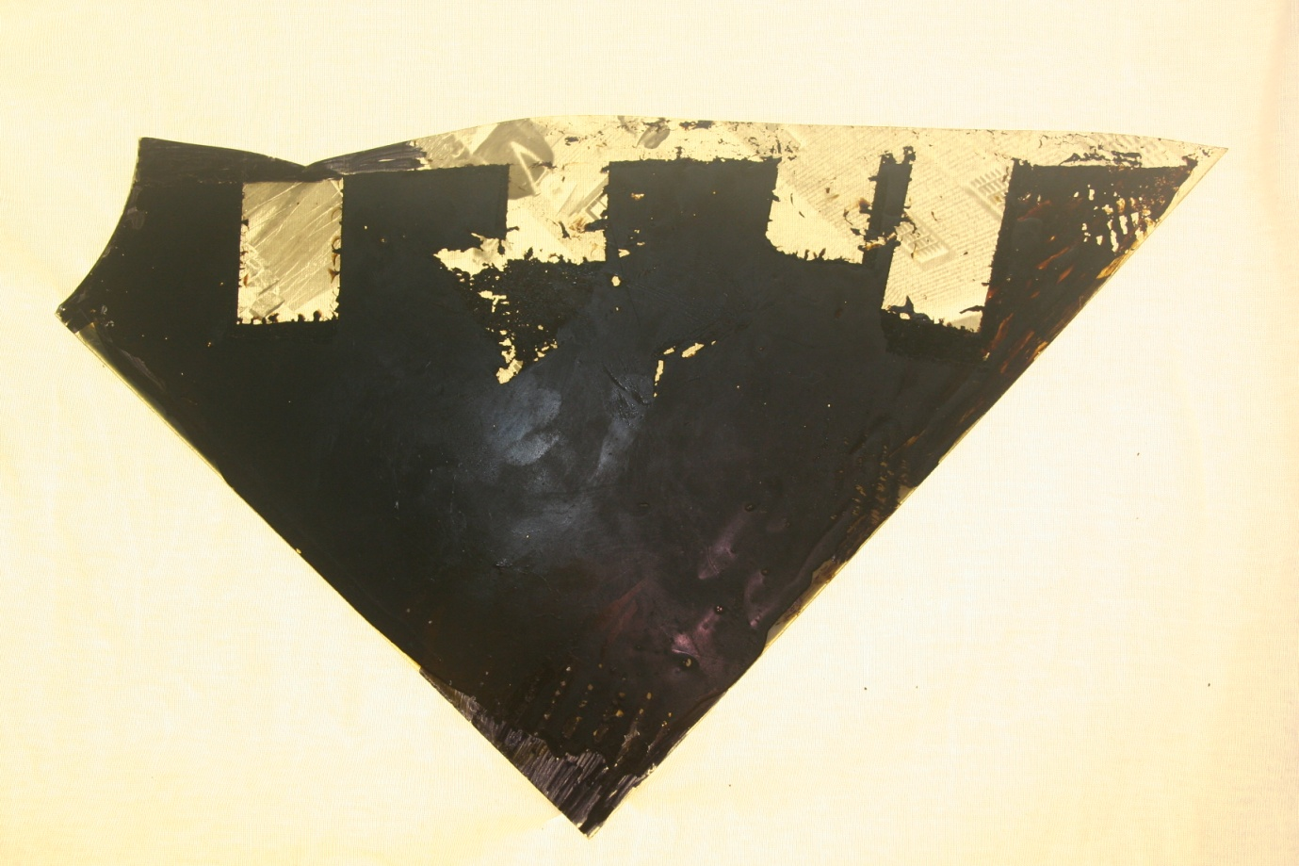
And after painting with glass paint:
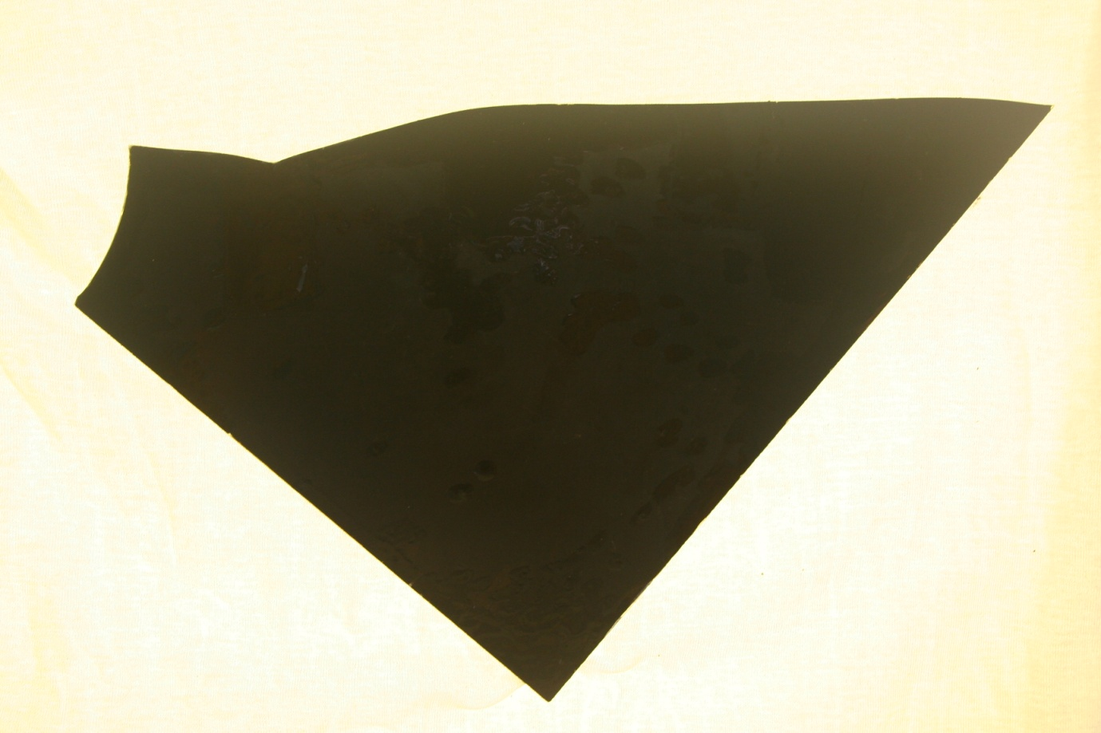

The face at the window
Earlier I mentioned about latent information, that only becomes visible after scanning. Because of the dirty glass, it was only when the Ambrotype had been scanned, that I saw there was a face at the window – a window today that is bricked up, but that room is currently part of the Humberside Police colour lab. Almost ghost-like in appearance, someone was watching the group, and the photographer recording them for posterity. I wonder who the person might have been and what he was thinking?
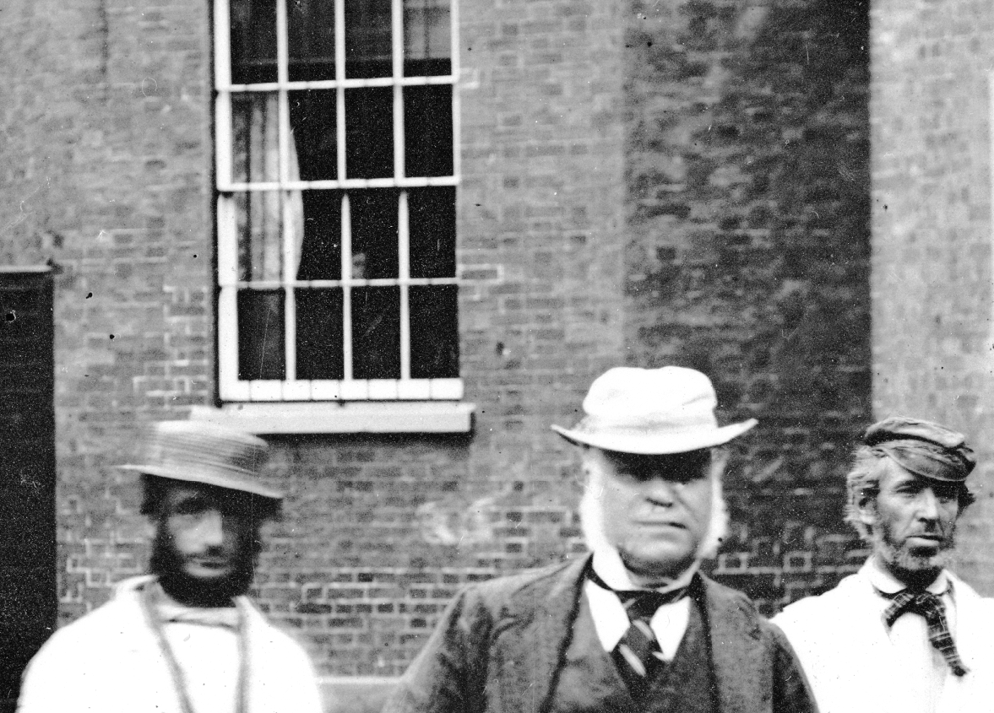
At this magnification, which is 260 times, you can just make out the faint mark on the face of the gentleman with the white hat, where the crack runs. But at 100%, the digital restoration renders the crack invisible. Notice the clarity of the man on the right who could obviously stand perfectly still.

Reassembling the photo and frame
Cleaning up the picture frame and glass was an easy task. The glass was washed in mild washing up detergent, then rinsed under running water before being allowed to air dry. Finally it was cleaned with a window glass cleaning solution.
The frame was cleaned with a damp cloth. The outer part is an oak frame, with a gilded inner section. A light cleaning of the glided portion brought back the lustre and a good quality hard beeswax polish has restored the wood.
The broken sheetwood back was stuck with Cascamite wood glue and clamped until it was dry.
I needed a means of holding the Ambrotype in place. As the frame is slightly larger than the 10”x8”, I made a very thin inner frame, with card the same thickness as the Ambrotype, 2.5mm, that it would just fit into. I drew in pencil round the Ambrotype onto the card and then round the frame glass. I cut the inner section out first and tried it for size. Then I cut the outer frame out, a much more fiddly task, and again tried it for size. Then I fitted the picture glass and card frame, before gently placing the two pieces of Ambrotype back into the picture frame.
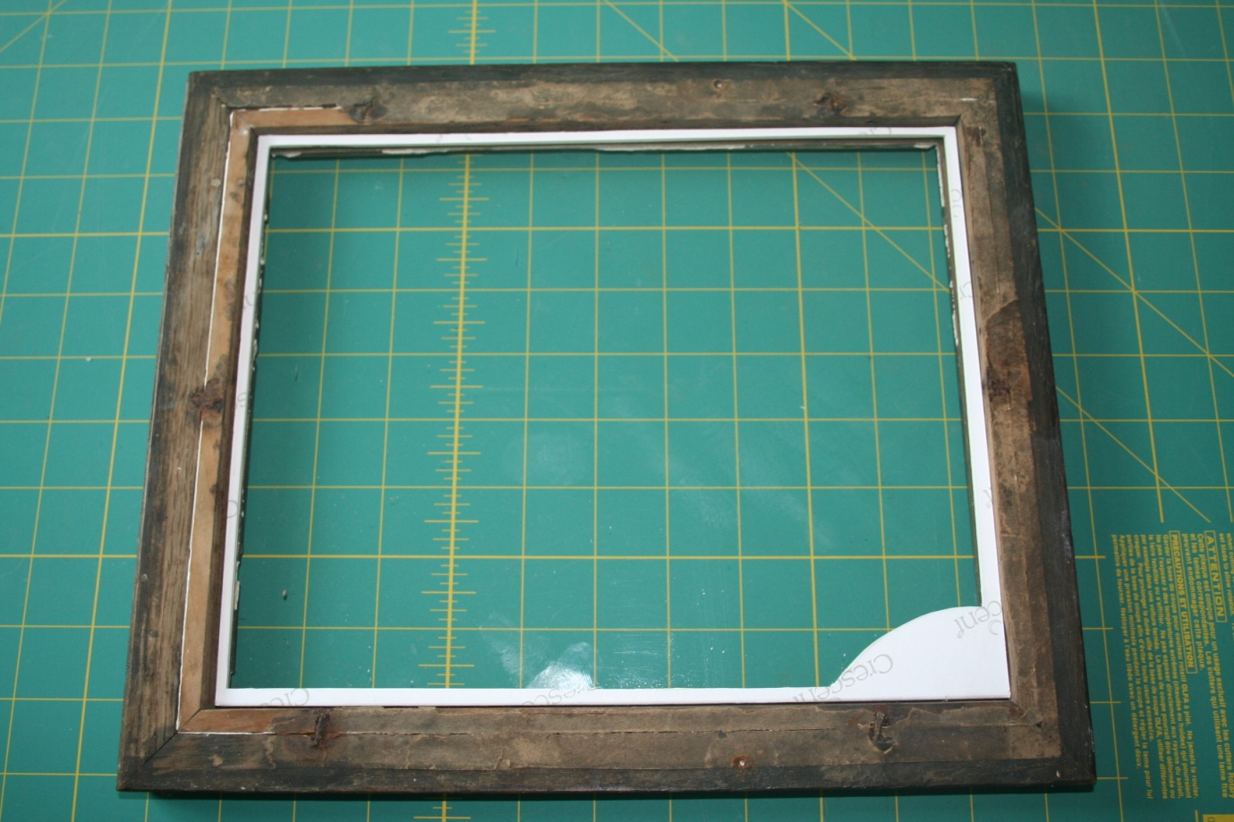
This is the result. However, the missing piece of glass negative cannot be replaced. But I am happy with the result. This is where Photoshop – or your favourite software some into play.
I will not bore you with the various layers and techniques I used, as they are only relevant if you use Photoshop, but here are the before and after images.

And this is the digitally restored image, taken in full sunlight it really shows of the detail. Even though the crack is still obvious, the two halves are at least joined together:

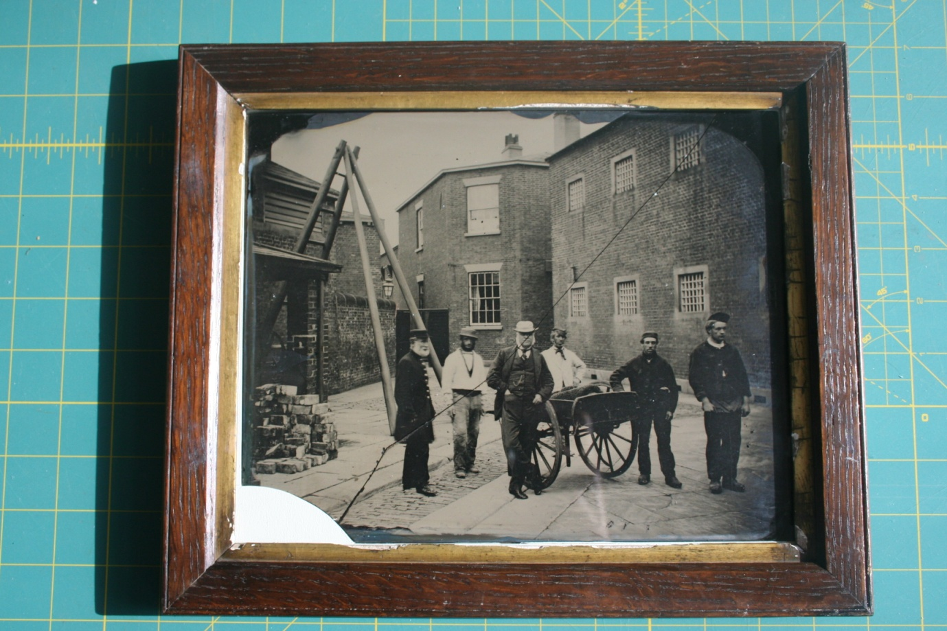

And finally, through the wonder of Photoshop, this is the finished image:

Lessons Learned
Go slowly and carefully. Stop when you are unsure and use the resources of the internet to try and find answers. Finding the answer often taken longer than actually using the knowledge gained to effect the repair.
Before doing some restoration procedure on a large area, ALWAYS try on a small, inconspicuous area first.
Scan photographs and negatives at the highest resolution you can and in full colour, even when they are black and white. If a black-and-white photo is scanned in colour, you can better distinguish between a mole and Mould. Mould frequently has colour in it when viewed at the pixel level (the view at which most restoration is done), and this gets lost if you either scan or save a file as black and white.
For more information, please read this informative article on scanners and scanning.
My photos are in albums or in frames. How do I preserve them?
Scan photographs separately but in the order they appear in an album. Make a note of their positions . Take a digital photograph of the full page/frame before you remove the individual photographs. As you disassemble something, take photographs of each stage. It makes it immeasurably easier when the time to reassemble them comes.
Photographs should then be stored separately , with any notes. Photo albums are not made of archive friendly material. The paper pages will have acids in them. Adhesives can discolour and mark photographs. If they have to be replaced, put them back in the order (which can sometimes help with their later identification).

Knowing when to stop
I am happy with the result. I could have used a glass glue to try and joint the two pieces of the Ambrotype together, but there are risks with old glass. The card frame works just as well.
The chips to the edge of the glass around the crack could be repaired and then the image touched in, but I judged that that is a skill I don’t have, so on the original they remain. On the digital copy, they are easy to clone away, to make them invisible.
Care needs to be taken, to make sure that what you do will not damage the image in the future. Things like making sure there are no residual chemical traces from the cleaner, on the glass facing the Ambrotype. That acid free card is used for the mount. That nothing that will be inside the paper backing is likely to make the delicate negative deteriorate. I also put a barrier paper under the wooden backing.
I did use the old Brad nails, but have covered the back with modern paper and masking tape to keep the worst of the dust out and have included some small sachets of desiccant.
I suspect that the well meaning person who effected the first repair with adhesive tape probably did so some 50 or more years ago. I am pleased he or she tried, rather than just writing off the photograph as having been broken. Perhaps in another 50 or more years, someone after me will decide that the picture needs a bit of a clean. When they open the back, they will find an envelope with a copy of this document inside, attached to the wooden backing........

Postscript
I entitled my article, “Why do we do what we do?” The reason, is because it matters. Do you have lots of memorabilia stored in boxes? Are photographs stored correctly? What would happen if you had a burst pipe at home, or burglars, or rodents or any other disaster? Is everything labelled with its history and provenance as you know it?
The reasons for collecting, having and keeping “memorabilia” will all vary, but my suggestion is that we all make what we do matter.

Some further reading links:
http://photo.net/digital-darkroom-forum/
http://www.retouchpro.com/forums/technique/
http://www.photographyboard.net/forums/
http://www.popphoto.com/how-to/2008/12/get-your-old-slides-and-negatives-scanner
http://www.archives.gov/preservation/family-archives/
http://www.archives.gov/preservation/technical/guidelines.pdf
http://www.scantips.com/
http://cool.conservation-us.org/byauth/messier/negrmcc.html
http://photo.net/black-and-white-photo-film-processing-forum/0065kv

